Renju lesson on February 22, 2001

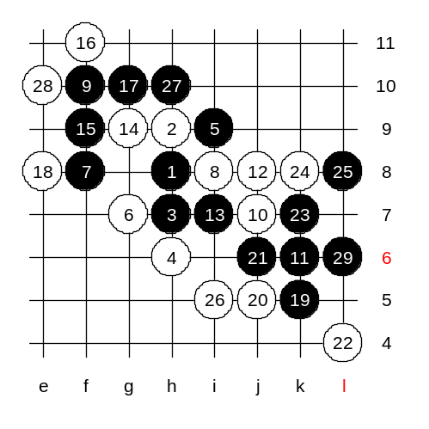
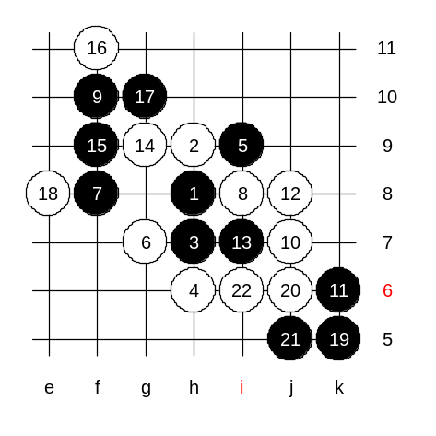
Hello all! Welcome to Online Renju Class. We will begin the lesson. Although we still continue with d8 today, we already finished learning the main variants of this opening. Today we will learn about Nakamura’s 14th move. As you remember from previous 2 weeks, the traditional 14th move is j6. Nakamura surprised me with that move in the second game of the match. At that time, I was not prepared for such move, and it took me long time to find the plan for black. How many of you have studied my 2nd game with Nakamura? Speaking of black 15th move, what ideas do you have? You are right about f9. I used that move too. Can anyone explain me why f9 was better than g10? The answer is, that black does not want to give up the important key point f9. If black just goes g10, then white takes f9, and black attack is failed. Now, white has two possible blocks, e8 and g8. We play e8 first. Do you know on which side will black attack now? As we learned before, usually we use one side material to connect the other side, and then continue the attack there. We cannot attack well on the left side because point e10 is forbidden 3x3. But black can use that forbidden point other way – by move j5, black could create a simple VCF threat towards e10 point. Can you see black VCF if black has a stone at j5? So, we can think as the j5 spot is granted for black. It does not mean we have to hurry to play there. So, we can play to j5 anytime, knowing that it will force white to block at i6 or g8. If we play j5 too early, then white blocks at i6, and after that black has no VCT while white has already many dangerous lines. So, what is the best choice for black now? I agree about k5, it is active, outside, and also keeps white under control. Now, we chose k5. How can white block it? Ok we try j5. Black win is quite simple.

We test another 20th move.
This is the medium level homework. Please find the black win.

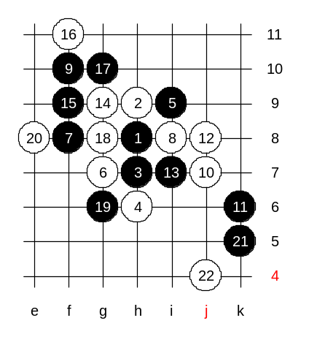
Now we learn about the stronger 18th move. The one that Nakamura played against me. I have tried different ways of attack here, but I have not found perfect plan yet. This white move is very strong. If you are not good at very active style, then I suggest you to use calm positional style, like I played in my game. Move 19-g6 is passive, but also very safe. Since black has no decisive advantage here, the 14th move has become very popular recently. The next move I played against Nakamura is 21-i10. However, I am not sure it is the best. Lets try to play k5 immediately. What can white do now. I am waiting for your suggestions. K5 is a new move, so it is interesting to discuss about what will happen. OK, we try 22-j4.
How can black win?
Lets do this way. This will be your advanced level homework. Please try to find black win. Since the position is new for me, I cannot guarantee that the win exists here, but I think it is a good challenge to try to find it, especially because the medium homework is quite easy one.

